The Eighth Annual Regulation Conference was chaired by Ian Welsh OBE, Chief Executive of the Alliance. The event was oversubscribed with over 300 stakeholders attending on the day which highlighting the importance of the regulation of healthcare professionals.
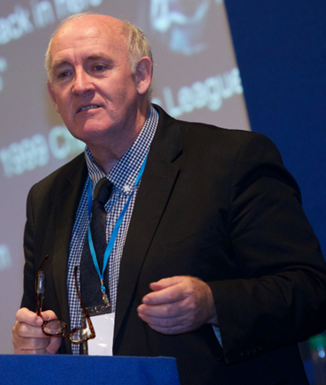
Following on from a welcome and introduction by the Chair, the first plenary session was presented by Professor Brian Webster-Henderson, University Dean of Learning and Teaching, Napier University and Elisabth Jelfs, Director of the Council of Deans of Health.
The session was titled, Rethinking Regulation – do we need to? which provided the audience with an interesting insight into the changing health and social care landscape from an educational perspective whilst setting the scene for the day.
Following on from the first plenary session, the Cabinet Secretary for Health, Wellbeing and Sport, Shona Robson provided the keynote speech. As well as outlining the Scottish Government’s current agenda, healthcare priorities and current developments in the Scottish Health and Social Care setting, the Cabinet Secretary confirmed the Scottish Government’s commitment to the UK wide regulation of healthcare professionals, which reflects the needs of a devolved Scotland and reiterated a commitment to a dynamic regulatory system that puts patient safety at its he art.
Throughout the remainder of the morning and after lunch, there were a number of parallel sessions which allowed conference delegates to choose workshops that were most relevant to them from a working or general perspective. This included panel sessions with Chief Executives of the regulatory bodies, interactive session based on the fitness to practise decision making process, a session on Revalidation within the Nursing and Midwifery Council and sessions on Professionalism.
The final Plenary Session of the day was presented by Anders Vege, Head of Section for Quality Improvement, Norwegian Knowledge Centre for the Health Services. The session was titled ‘Tales from the edge’ and provided an interesting insight into quality improvement from a Norweigian perspective.
To round of the day, Mr Welsh provided some final thoughts before closing the conference.
The Scottish Government greatly appreciates all the support from those who continue to help to make this unique United Kingdom event a great success. We would also like to thank the tremendous support and assistance yet again provided by the regulatory bodies making this event an exemplar of joint working and cooperation.

