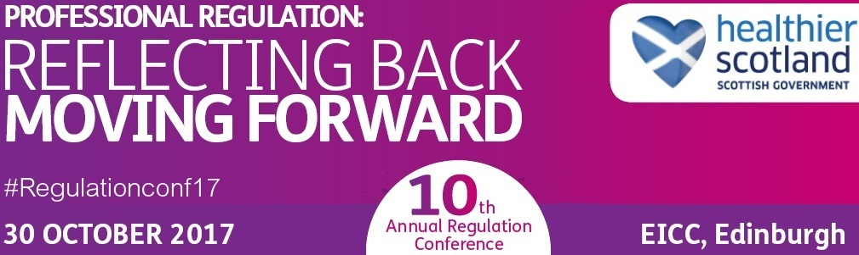

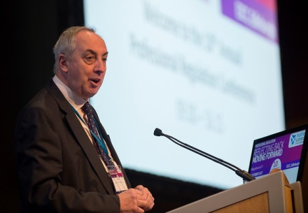
The Tenth Annual Regulation Conference was chaired by Jim Martin who is currently a member of the Scottish Governments Legal Services Regulation Review Panel.

The event took place on 30 October 2017 and the theme for the day was Professional Regulation Reflecting Back, Moving Forward. It continues to be the only event of its kind in the UK and it receives support by a wide range of UK stakeholders.

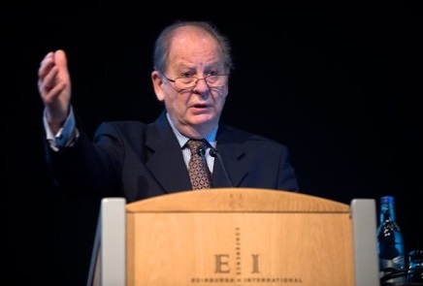
Following on from a welcome and introduction by the Chair there was a headline speech by Professor Sir Ian Kennedy. Sir Ian holds several prominent posts and is an Honorary Fellow of six Royal Colleges. Sir Ian spoke about failings in the system of care, citing the case of surgeon Ian Patterson.

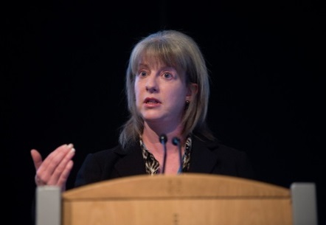
Following on from Sir Ian’s speech was a keynote speech given by Shona Robison MSP, Cabinet Secretary for Health and Sport. It focussed on the Scottish Government’s commitment to the UK wide regulation of healthcare professionals, support of the comprehensive view of regulation and the upcoming consultation on regulatory reform. The Cabinet Secretary also reiterated the commitment to a dynamic regulatory system that puts patient safety at its heart as well as highlighting the current developments in Scottish Health and Social Care.

After the Cabinet Secretary’s speech there were a number of parallel sessions run via workshops. The topics covered were widely varied and covered such subjects as Health and Social Care Standards as well as regulatory reform. There was an emphasis on the future development of regulation in different contexts and the likely impact of this.

Throughout the remainder of the day there were a number of parallel sessions which enabled conference delegates to choose workshops that were of interest to them either from a personal or professional perspective. There were also a number of panel sessions with Chief Executives of regulatory bodies which included an audience question and answer session at the end. There were plenty of opportunities for networking throughout the day and feedback following the event was positive with the keynote speeches being well received.

