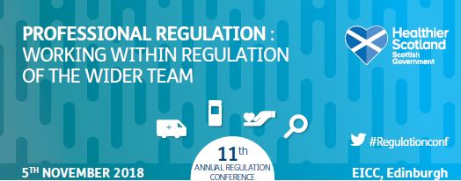

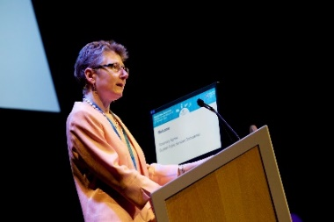
The eleventh Annual Regulatory Event took place on 5 November 2018 at the Edinburgh International Conference Centre (EICC). The theme of the day was “Professional Regulation: Working within regulation of the wider team”. The event continues to be the only event of its kind in the UK and it receives support from a wide range of UK stakeholders.

The event was chaired by Rosemary Agnew who has been the Scottish Public Services Ombudsman since 1 May 2017. Rosemary’s previous roles have included that of Scottish Information Commissioner and various roles in relation to public sector complaints; including the Scottish Legal Complaints Commission and Local Government Ombudsman in the UK. From her time in these roles, Rosemary has a gained a unique insight into Scottish Public Services.

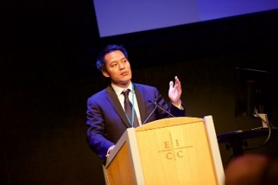
Following on from a welcome and introduction by the Chair, the first plenary session took place which was hosted by Dr Kevin Fong. Dr Fong is a consultant anaesthetist at University College London Hospital and a pre-hospital doctor with Kent, Surrey and Sussex Helicopter Emergency Medical Service. Dr Fong is also a Wellcome Trust Fellow and holds an honorary chair in Public Engagement and Innovation at the Department of Science, Technology, Education and Public Policy (STEaPP) at University College London.

Dr Fong’s speech was entitled ‘Life, Death and Mistakes’ and he spoke about his experiences - both as a clinician and with NASA - and how these have given him a unique perspective on the management of risk and technology in modern complex systems. His speech was well received by the audience and at the end there was a question and answer session which the audience engaged well with.
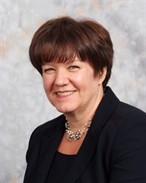Following Dr Fong’s presentation, a keynote address was given by Professor Fiona McQueen, the Chief Nursing Officer (CNO) for Scotland. The CNO spoke about Healthcare Regulatory Reform and the Scottish Government’s commitment to Four-Country Working; the Health and Social Care sector; the Safe Staffing Bill; and, within the context of the UK’s withdrawal from the EU, the importance of the EU/EEA workforce in Scotland,

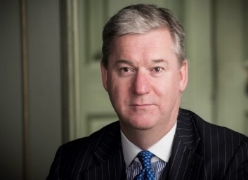
The final plenary session was hosted by Andrew Webster QC who drew on his wealth of experience as a Legally Qualified Chair and Legal Assessor to advocacy. Andrew spoke about and contrasted different disciplinary approaches taken by healthcare regulators, and highlighted some practical consequences for individuals and the public from a regulatory point of view.

Throughout the day there were a number of parallel sessions which enabled delegates to choose workshops that were of interest to them whether from a personal or professional perspective. There were three panel sessions which included senior members of the regulatory bodies and each of these sessions concluded with an audience question and answer session. There was plenty of opportunities for networking throughout the day and feedback following the event has been positive with the presentation by Dr Kevin Fong being particularly well received by the audience.

